

**Princess Sumaya University for Technology**

**King Abdullah II School for Electrical Engineering**

**Microprocessors and Embedded Systems**

|  |  |
| --- | --- |
| **Student Names** | **Student number** |
| Rakan AlShrouf | 20190344 |
| Abdallah Abidy | 20190520 |
| Amr Zaben | 20190064 |

Table of Contents

Abstract 2

Introduction and Background 2

Mechanical Design 3

Electrical Design 6

Software Design 7

Problems and Recommendations 7

Conclusion 8

# Abstract

The demand for crop production and quality has increased drastically, thus the need for greenhouses. Greenhouse is a building designed for creating the best environmental conditions by artificially maintaining its environment. Nowadays, using embedded systems to monitor greenhouse is quite significant, especially for control and monitoring of greenhouse systems. Since the crop growth is independent of the natural environment, a 24/7 monitoring is mandatory. In this project we will be able to control the temperature, light, and moisture of the soil to have the optimal conditions for the best quality and production for plants.

# Introduction and Background

Greenhouses are structures that are used to grow plants in a controlled environment. They can be used to grow a wide variety of plants, including fruits, vegetables, and flowers. They are typically made of glass or plastic and are designed to trap heat inside, creating a warm environment for plants to grow.

Embedded systems are computer systems that are integrated into other devices or products. These systems are designed to perform specific tasks and are often used in a wide range of applications, including industrial control, automotive systems, and consumer electronics.

In the context of greenhouses, embedded systems can be used to control and monitor various aspects of the greenhouse environment, such as temperature, moisture, and lighting. This can help to optimize growing conditions and improve crop yields. Additionally, embedded systems can be used to automate various tasks, such as watering and fertilizing, which can save time and labor costs.

Overall, the integration of embedded systems in greenhouses can provide a more efficient and effective way to manage and control the greenhouse environment, resulting in better crop yields and quality.

# Mechanical Design

The dimensions are 70cmx40cm and height is 30cm.

Watering and Lighting System:

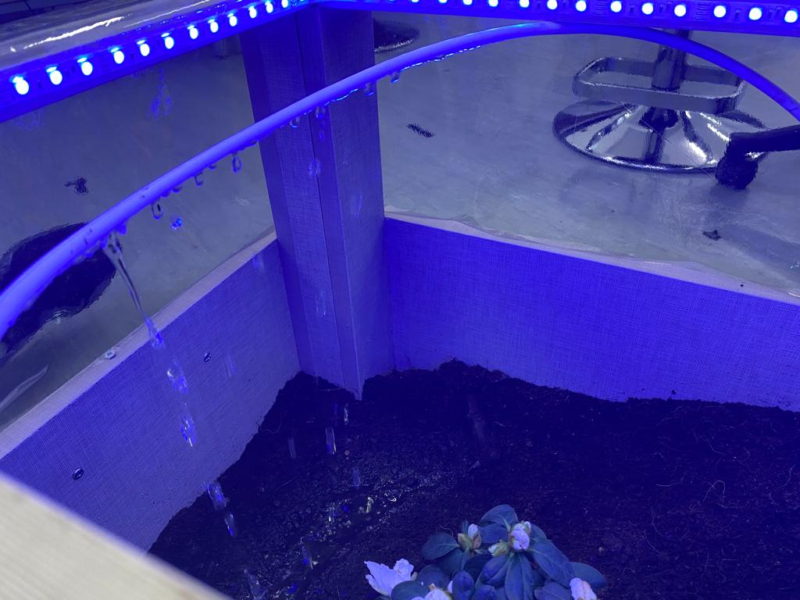

Reading the temperature:

Cooling System:

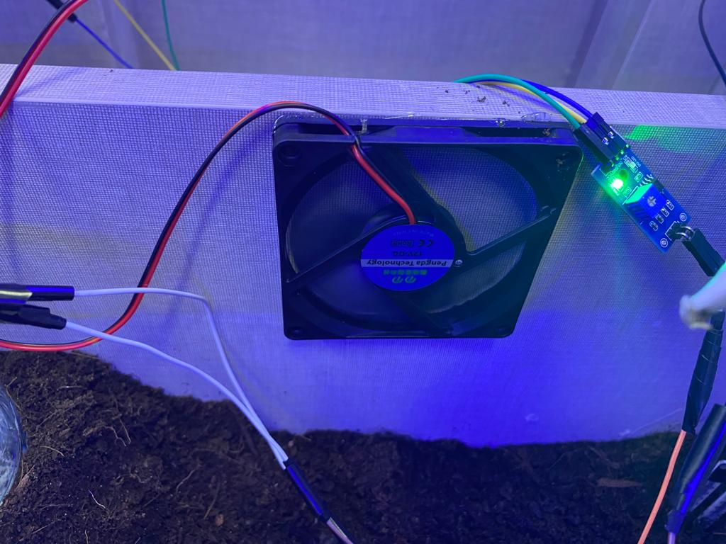

# Electrical Design

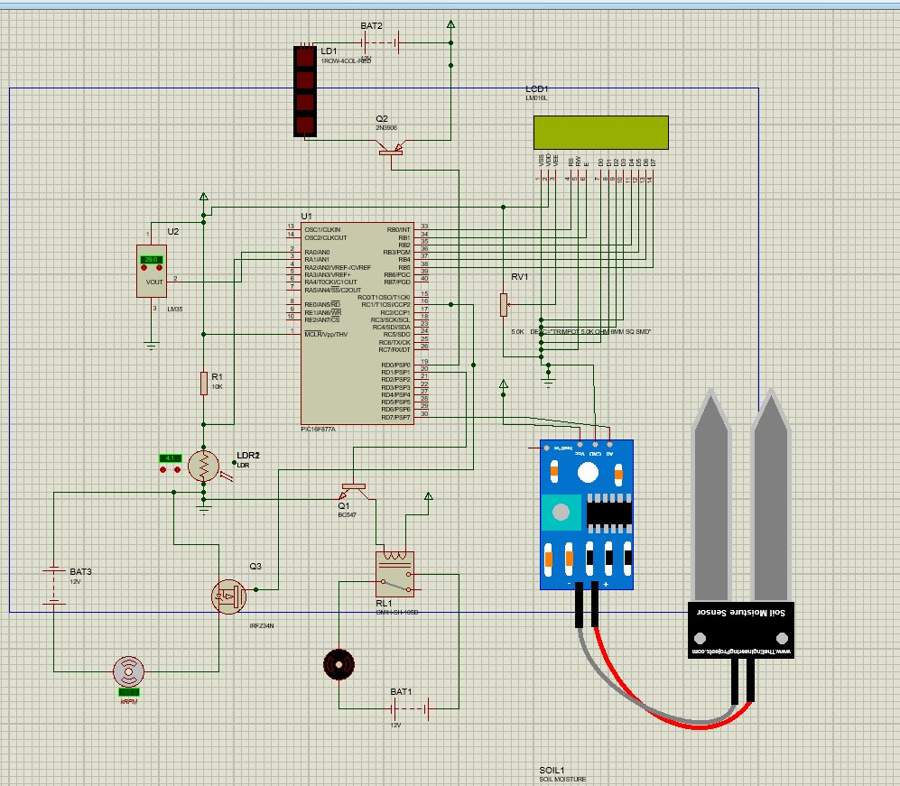

# Software Design

# Problems and Recommendations

Lack of heating system in extreme low temperatures, and the solution is to install an electrical heater that is controlled by the output from the temperature sensor.

# Conclusion

In conclusion, a smart greenhouse is a technologically advanced solution for growing plants in controlled environments. It combines traditional greenhouse methods with modern technology to optimize the growing conditions for plants. The use of sensors, automation, and data analysis allows for precise control of factors such as temperature, moisture, light, and water, resulting in increased yields and improved plant health. Overall, smart greenhouses represent a significant advancement in the field of agriculture and have the potential to revolutionize the way we grow plants. Embedded systems are a technology that allows for the integration of computer systems into a wide range of everyday devices and appliances. These systems are designed to perform specific tasks and are characterized by their small size, low power consumption, and real-time capabilities, with their aid we were able to produce this Smart Greenhouse.